**DAILY ONLINE ACTIVITIES SUMMARY**

|  |  |  |  |  |  |  |  |  |
| --- | --- | --- | --- | --- | --- | --- | --- | --- |
| **Date:** | | **27/05/2020** | | | | | | |
| **Name of the Faculty** | | **Shilpa** | | | | | | |
| **No. of Students Allotted for monitoring** | | | | | **19** | | | |
| **Progress** | | | | | **Good** | | | |
| **Whether collected report from all the allotted students** | | | | | **14 submitted** | | | |
| **Online Test Summary** | | | | | | | | |
| **Subject** | **Object Oriented Concepts [18CS45]** | | | | | | | |
| **Semester** | **4** | | | **Duration** | | | **30** | |
| **No. of students Taken** | | | **95** | **Passing %** | | | **96%** | |
| **Certification Course Summary** | | | | | | | | |
| **Course** | | The Future of Artificial Intelligence**,** Deep learning , Data Science | | | | | | |
| **Certificate Provider** | | ICT Academy, Pantec | | | | **Hours** | | **5 days, 2 hours** |
| **Coding Challenges** | | | | | | | | |
| **Problem Statement: -** | | | | | | | | |
| **Status: -** | | | | | | | | |
| **Uploaded the report in Github** | | | | | **YES** | | | |
| **If yes Repository name** | | | | | <https://github.com/shilpahassan/Daily-Report> | | | |
| **Uploaded the report in slack** | | | | | **YES** | | | |

Online Test Details: (Attach the snapshot and briefly write the report for the same)

Certification Course Details: (Attach the snapshot and briefly write the report for the same)

Coding Challenges Details: (Attach the snapshot and briefly write the report for the same)

Online Test Detail:

Conducted MCQ Test of module5 (Swings and Applets) which contained 30 question. Totally 94 students have taken the test and the response is good out of 94 only 4 members have scored below 12.

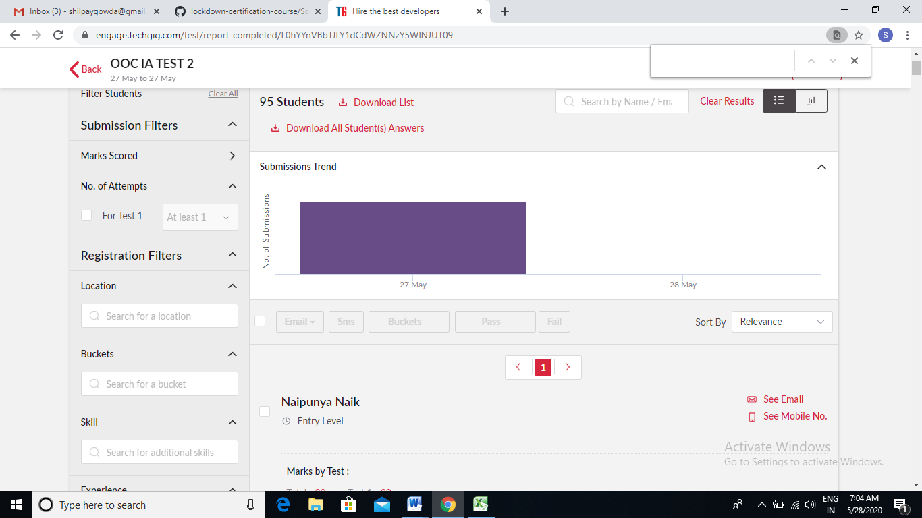

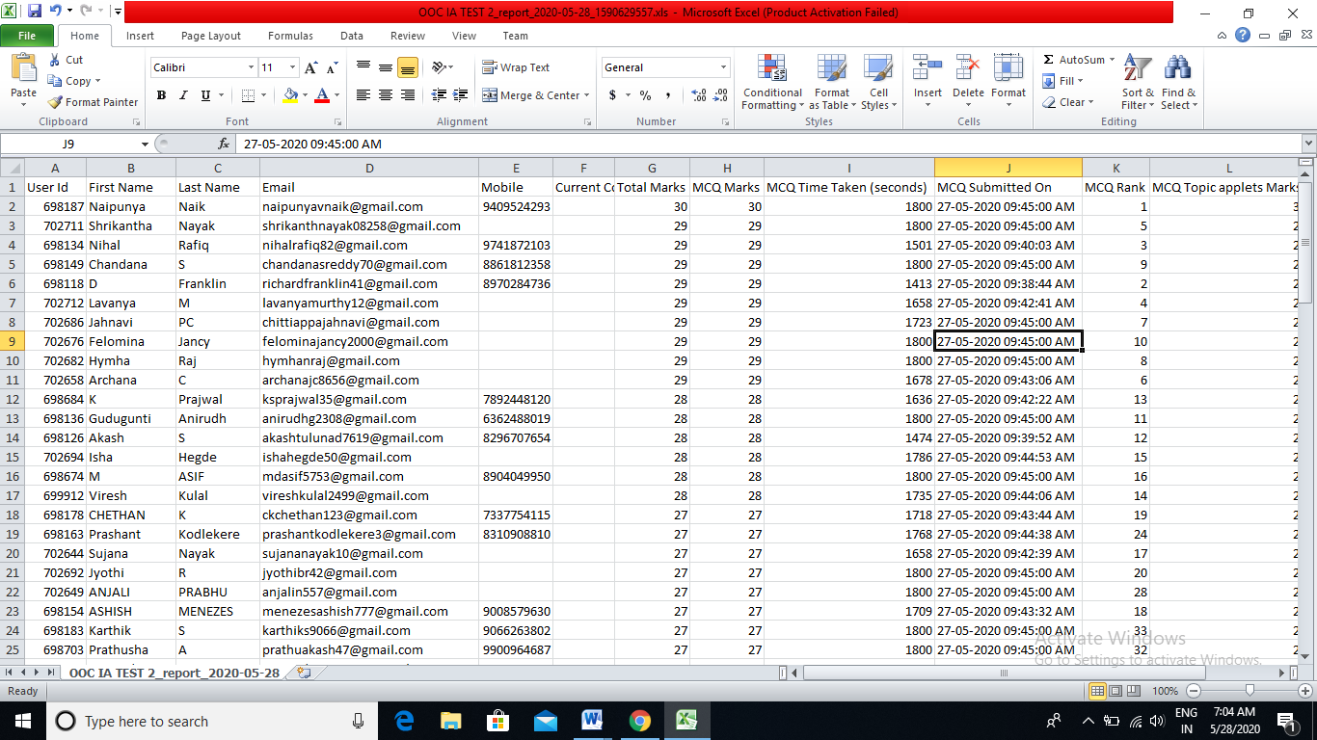

**Certification Course Summary**

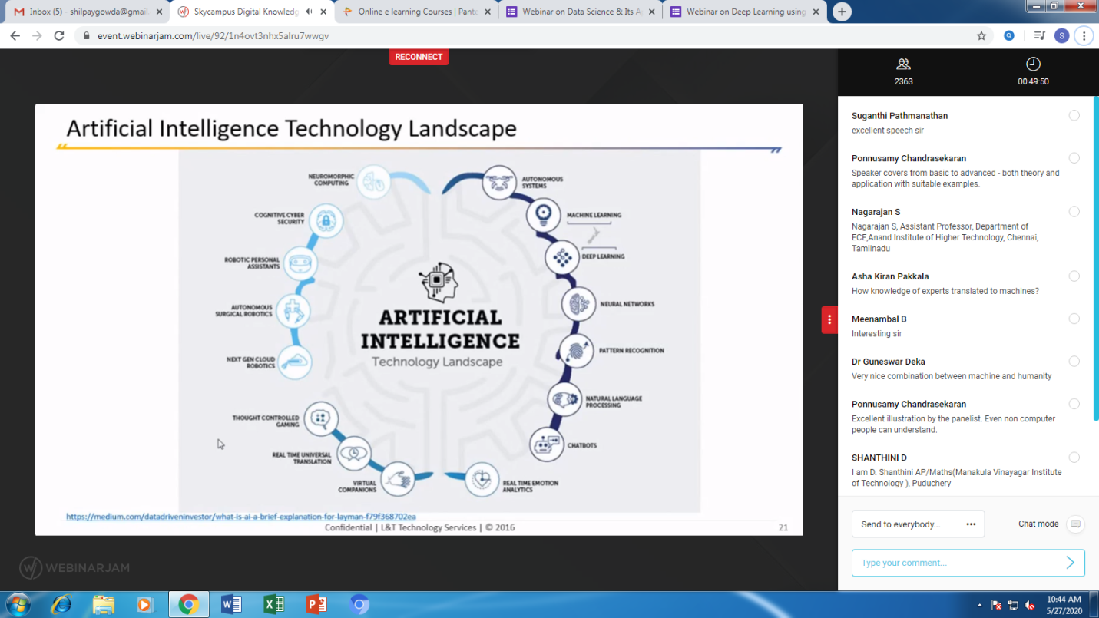

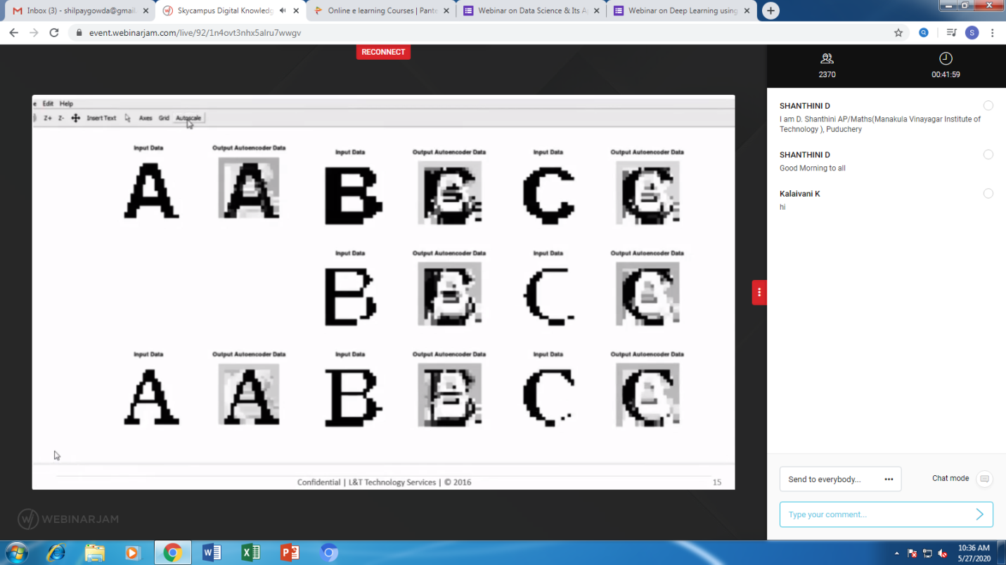

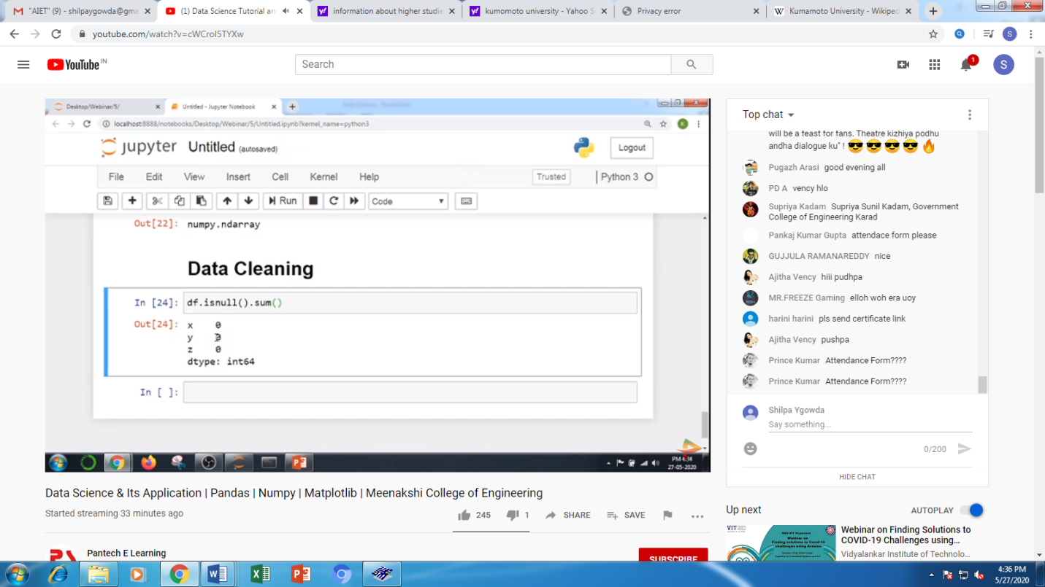

**Students Report:**

